Experiment 5:
Aim: Write a Pandas program to create a bar plot of the trading volume of Alphabet Inc. stock between two specific dates.
Python code:
import yfinance as yf
import matplotlib.pyplot as plt

stock = yf.download("GOOGL", start="2023-01-01", end="2023-03-31")

# Flatten MultiIndex columns if present
if stock.columns.nlevels > 1:
stock.columns = stock.columns.get_level_values(0)

plt.figure(figsize=(12,5))
plt.bar(stock.index, stock["Volume"])

plt.title("Alphabet Inc. Trading Volume")
plt.xlabel("Date")
plt.ylabel("Volume")
plt.xticks(rotation=45)
plt.tight_layout()
plt.show()
output:

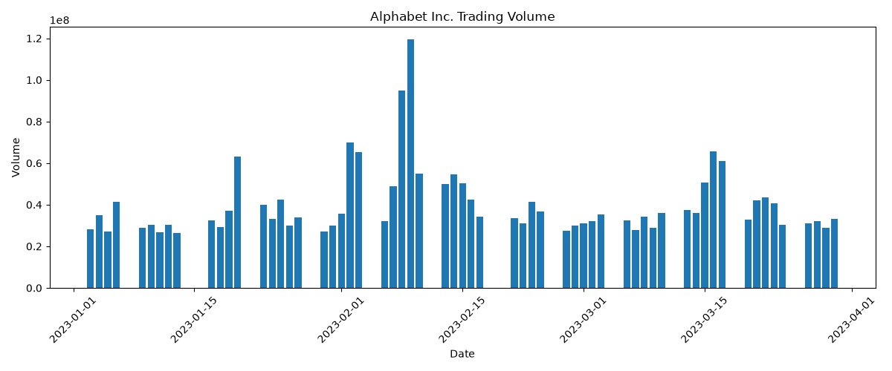
Experiment 6:
Aim: Write a Pandas program to create a scatter plot of the trading volume/stock prices of Alphabet Inc. stock between two specific dates.
Python code:
import yfinance as yf
import matplotlib.pyplot as plt
# Download stock data
stock = yf.download("GOOGL",
start="2023-01-01",
end="2023-06-30")
# Scatter plot
plt.figure(figsize=(8,6))
plt.scatter(stock["Volume"], stock["Close"])
plt.title("Trading Volume vs Closing Price")
plt.xlabel("Trading Volume")
plt.ylabel("Closing Price ($)")
plt.grid(True)
plt.show()
output:
